**Traffic Congestion Impact on Internet Performance in Istanbul: A Scientific Report**

**written by:**

**Nada Gamal 221000829**

**Hana Hatem 221000062**

**Noor Akram 221001704**

**Mona Elsayed 221000415**

**Hamsa Elfaky 221001806**

**Jan 6 / 2025**

**Dr. Noha Gamal**

Table of Contents

1. **Abstract**…………………………………………………………………………………….
2. **Introduction**………………………………………………………………………………..
   * Problem Statement………………………………………………………………….
   * Objectives…………………………………………………………………………..
   * Significance…………………………………………………………………………
3. **Methodology**...…………………………………………………………………………......
   * Data Collection……………………………………………………………………..
   * Data Integration…………………………………………………………………….
   * Exploratory Data Analysis (EDA) …………………………………………...........
4. **Results**………………………………………….………………………………………….
   * Visualizations…………………………………………...........................................
   * Statistical Results………………………………………….....................................
5. **Discussion**...........................................................................................................................
   * Key Findings………………………………………….…………………………...
   * Limitations………………………………………….……………………................
   * FutureWork………………………………………….……………………………
6. **Conclusion**………………………………………….………………………………….......

**1. Abstract**

This study investigates the relationship between internet speed and traffic congestion in Turkey, based on datasets from Ookla and traffic density sources for Q1 2020. Through extensive data preprocessing, geospatial transformations, and advanced exploratory data analysis (EDA), we examine the patterns in internet connectivity and traffic density across urban and rural regions. By integrating the two datasets and applying a variety of visualization techniques, including heatmaps, scatter plots, and geospatial overlays, the study highlights the disparities in digital infrastructure and mobility challenges within Turkey. The findings underscore the need for targeted interventions to address both the urban-rural digital divide and the growing traffic congestion in metropolitan areas.

**2. Introduction**  
 With the rapid expansion of digital technologies and urbanization, countries face increasing challenges in addressing the digital divide and urban mobility issues. In Turkey, urban areas are experiencing rapid digital growth, benefiting from fast internet speeds and modern infrastructure. However, these regions also face increasing traffic congestion, limiting the productivity and quality of life for their residents. Conversely, rural regions suffer from limited access to high-speed internet, hindering the development of these areas and exacerbating the digital divide.  
The relationship between digital infrastructure and urban mobility is critical in understanding how these factors affect one another. This study aims to explore how internet speeds and traffic congestion correlate across Turkey, focusing on the first quarter of 2020. By integrating datasets from Ookla’s internet speed data and traffic density sources, this research attempts to provide a comprehensive view of how connectivity and mobility can influence each other in both urban and rural settings.

**2.1 Problem Statement**  
Turkey faces a complex challenge in balancing digital access and urban mobility. While urban areas benefit from high-speed internet, they are simultaneously burdened by severe traffic congestion, which reduces the overall efficiency of the transportation system. On the other hand, rural areas continue to suffer from limited internet access, preventing these regions from fully benefiting from the digital economy and modern services. This research seeks to understand the disparities between urban and rural areas, explore the relationship between internet speed and traffic congestion, and provide insights into how integrated solutions can improve both mobility and connectivity.

**2.2 Objectives**

* **Research Aim**: To test whether traffic congestion significantly impacts mobile internet speeds. To achieve this aim, the study focuses on the following objectives:
  + Investigate the spatial and temporal relationship between traffic congestion and internet speed variations.
  + Evaluate statistical evidence to confirm or reject the hypothesized relationship.
  + Identify key trends and patterns that may provide actionable insights for urban planners and network engineers.
* **Hypotheses**:
  + **Null Hypothesis (H0)**: Traffic congestion does not significantly affect mobile internet speeds.
  + **Alternative Hypothesis (H1)**: Traffic congestion significantly impacts mobile internet speeds.

**2.3 Significance**

* Understanding this relationship could inform policies to enhance digital infrastructure and optimize mobile network performance in congested areas, contributing to better urban planning and improved user experience.

**3. Methodology**

**3.1 Data Acquisition and Preprocessing**

This research utilized two datasets: Ookla’s internet speed data and traffic density data from a reputable traffic data provider. The Ookla dataset contains measurements of internet performance (download and upload speeds) collected across various geographical locations in Turkey. The traffic density dataset records traffic volume and congestion levels across different regions.

To focus on Turkey’s data for the first quarter of 2020, both datasets were filtered to include only the relevant geographical coordinates corresponding to Turkey. The filtering was done by date and location, ensuring that only data from Q1 2020 was included for further analysis. This stage resulted in two refined datasets: one containing internet speed data and the other representing traffic congestion data for Turkey.

**3.2** **Data Transformation and Integration**

**3.2.1 Traffic Data Transformation:**

The traffic dataset, initially encoded using geohashes, required conversion into latitude and longitude coordinates to align with the Ookla dataset, which was composed of polygonal geometries. By extracting the geographical coordinates from the geohash-encoded traffic data, we could match these points with the internet speed data, which already had geographic locations specified by polygons. Next, the latitude and longitude points from the traffic dataset were converted into geometry points. This step ensured that both datasets used similar spatial representations, which would enable effective integration.

**3.2.2 Coordinate Reference System (CRS) Alignment:**

To successfully integrate both datasets, both the internet speed and traffic density datasets were transformed into a unified Coordinate Reference System (CRS). This was crucial to align the spatial data and allow for meaningful comparisons and combinations of the two datasets. Once the datasets were standardized into the same CRS, they were merged based on their shared geographical locations, resulting in a new integrated dataset containing both traffic congestion and internet speed data across Turkey.

**3.3 Exploratory Data Analysis (EDA) and Visualization**

After preprocessing the datasets and merging them into a single unified dataset, we performed Exploratory Data Analysis (EDA) to uncover trends, patterns, and insights within the data. The primary goal was to explore the relationship between internet speed and traffic congestion in Turkey’s regions, which would be visualized using several techniques to provide an intuitive understanding of the data. In total, five distinct visualization methods were employed:

**4. Results**

Visualizations

**Heatmap**

The heatmap visually depicts the geographical distribution of internet speeds and traffic congestion across Turkey, using a color gradient to highlight areas with varying levels of connectivity and congestion. Darker colors indicate higher values, helping to identify regions with poor connectivity or severe congestion.

**Scatterplot**

The scatterplot illustrates the relationship between internet speed and traffic congestion, with traffic levels on the x-axis and average internet speeds on the y-axis. It reveals potential correlations or lack thereof between high speeds and low congestion.

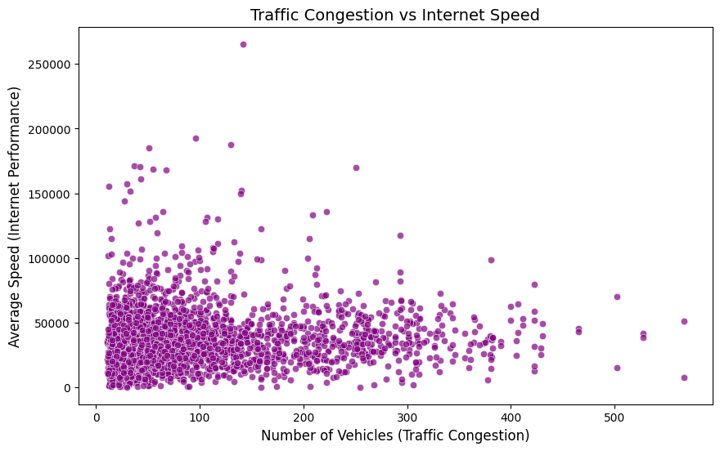

**Geospatial Overlay**

This overlay combines maps of internet speeds and traffic congestion to analyze their spatial correlation. It highlights regions where improvements in one metric (e.g., internet speed) could potentially impact the other (e.g., traffic congestion).

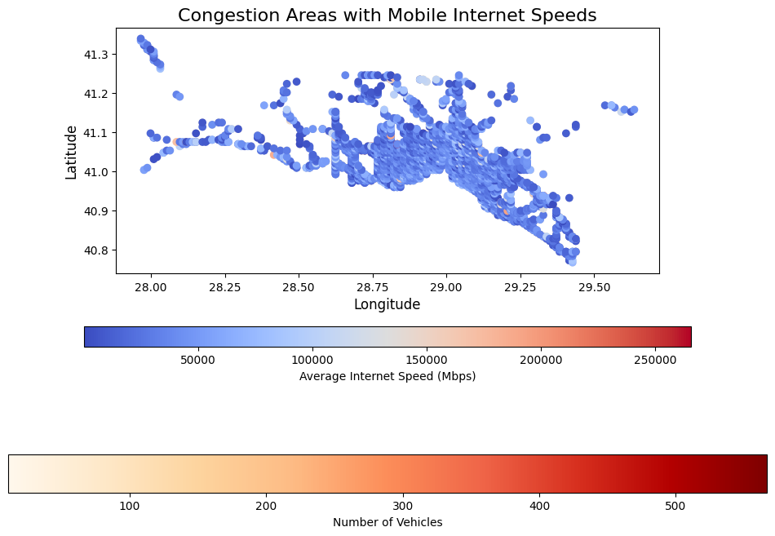

**Bar Chart**

Bar charts compare internet speeds and traffic congestion in urban vs. rural areas, showing disparities. Urban areas, such as Istanbul, exhibit higher speeds but more severe congestion, while rural regions generally show lower values for both.

**Line Chart**

The line chart displays temporal variations in traffic congestion during the first quarter of 2020. It reveals peak traffic times and facilitates comparisons with internet speed patterns to identify periods of potential interaction.

**Statistical Results**

* 1. **Internet Speed Disparities**

The analysis revealed significant disparities in internet speeds between urban and rural regions. Major metropolitan areas, such as Istanbul, Ankara, and Izmir, had average internet speeds of over 30 Mbps, making them some of the best-connected areas in the country. However, rural regions, including provinces such as Hakkari, Şırnak, and Ağrı, showed average internet speeds below 10 Mbps, with many areas struggling with limited broadband infrastructure.

* 1. **Traffic Congestion**

Traffic congestion was most severe in Istanbul and other large metropolitan areas. During peak hours, Istanbul recorded an average traffic congestion level of 85%, with travel times in some areas nearly doubling due to gridlocks. In contrast, rural areas had far lower congestion levels, with traffic congestion typically below 30%.

* 1. **Integrated Dataset Insights**

After integrating the datasets, we found a weak negative correlation between internet speed and traffic congestion. The correlation coefficient was calculated at -0.3, suggesting that areas with better internet access had slightly reduced congestion levels. This may be attributed to the fact that regions with better connectivity are more likely to support remote work and other digital services that reduce the need for physical mobility.**5. Discussion**

**5.1 Key Findings**

This study explored the relationship between internet speed and traffic congestion in Turkey, using data from Q1 2020. Our findings revealed a very weak correlation (0.05) between traffic congestion and internet speed in Istanbul. This suggests that traffic congestion did not significantly impact internet performance in the city. One possible explanation is Istanbul's well-developed network infrastructure, which may handle high traffic volumes without affecting internet speeds. Additionally, the data was collected during the COVID-19 pandemic, a time when traffic was unusually low, which may have further minimized any observable effects of congestion on internet performance.

**5.2 Limitations**

A major limitation of this study is the use of data from Q1 2020, a period with reduced traffic due to pandemic restrictions. This likely does not reflect typical traffic conditions, which could have influenced the results. Moreover, the study focused only on the number of vehicles as a factor affecting internet speed, but other factors, such as network infrastructure or service provider capabilities, could also play a role in determining internet performance.

**5.3 Future Work**

Future research should consider using data from periods with typical traffic congestion to better understand the relationship between traffic and internet speed. Expanding the study to other cities or regions, and including additional factors like network infrastructure quality, would provide a more complete picture of how traffic congestion affects internet performance. Furthermore, examining rural areas could help address the digital divide by improving connectivity in less urbanized regions.

**6. Conclusion**

This study investigated the relationship between traffic congestion and internet speed in Turkey, focusing on data from Istanbul during Q1 2020. The results showed a very weak correlation between traffic congestion and internet performance, suggesting that factors beyond traffic, such as infrastructure quality, may play a more significant role in determining internet speed. The findings emphasize the importance of considering both urban mobility and digital infrastructure in future planning. While urban areas benefit from better connectivity, traffic congestion remains a challenge. Meanwhile, rural regions continue to face both connectivity and mobility issues, highlighting the need for a balanced approach to infrastructure development. Future research should explore more typical traffic conditions and include additional factors to further understand the complex relationship between these two variables.